Self-Care 101: Practicing the Art of Self Love

How can we be a force of love in the world if we haven’t learned how to love ourselves?

In this experiential program, Rev. Katherine Gray Silvan, LMSW engages her audience in the Art of Self-Care. Through dynamic visuals and her provocative and lively presentation style, she shares research-based data covering a full spectrum of areas that focus on the practice of self-love.

- What is the distinction between being selfish and self-full?
- How can we assess our own perceptions of healthy self-care?
- Can we honor ourselves by setting clear boundaries in relationships?
- What is the connection between our thoughts and behavior?

This one-hour program explores these questions and more, offering short and simple techniques for creating skills in self-care that help us navigate our fears and dreams in the complex world we live in. Strategies include: laughter as medicine, grounding, gratefulness and conscious breathing, for the purpose of creating and sustaining holistic well-being.

Participants will not only spend the session caring for themselves, but they will walk away with the beginnings of a self-care tool box that they can utilize and build on throughout their lives. All will be encouraged to embrace a personal commitment to be a force of love in the world, by first loving oneself.

Katherine Gray Silvan, LMSW
Ksilvan@sbcglobal.net
www.katherinesilvan.com
203-912-5252

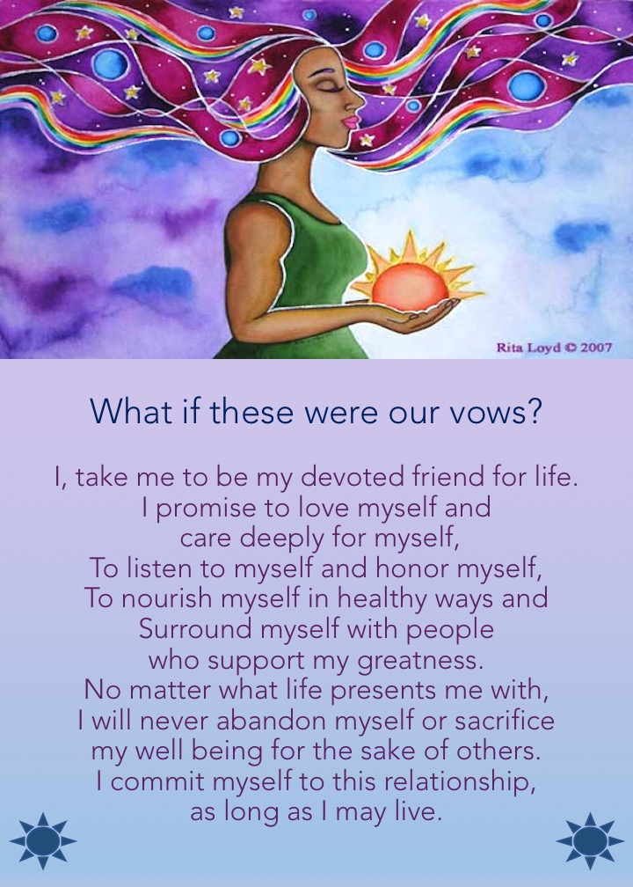

Katherine Gray Silvan, LMSW
Ksilvan@sbcglobal.net
www.katherinesilvan.com
203-912-5252

